**Temperature Sensor Module (DHT11)**

**Introduction**

The **DHT11** is a commonly used **Temperature and humidity sensor** that comes with a dedicated NTC(Negative Temperature Coefficient) to measure temperature and an 8-bit microcontroller to output the values of temperature and humidity as serial data.

The DHT-11 is a digital-output, relative humidity, and temperature sensor. It uses a capacitive humidity sensor and a thermistor to measure the surrounding air, and sends a digital signal on the data pin.

DHT11 humidity and temperature sensor is available as a sensor and as a module. The difference between this sensor and module is the pull-up resistor and a power-on LED. DHT11 is a relative humidity sensor. To measure the surrounding air this sensor uses a thermistor and a capacitive humidity sensor.

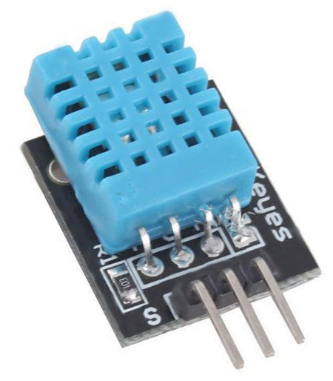 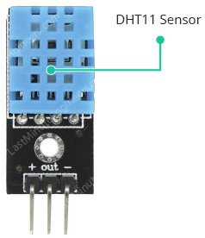

**Working of DHT11**

Inside the DHT11, there is a humidity sensing component along with a Thermistor. Humidity sensing component has two electrodes with moisture holding substrate sandwiched between them.

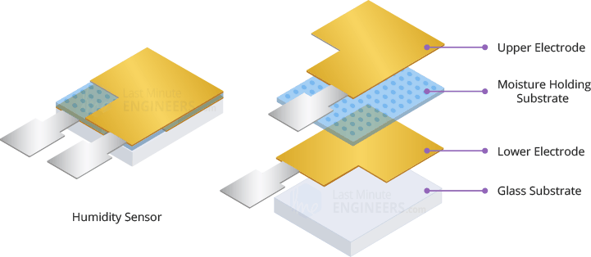

The ions are released by the substrate as water vapor is absorbed by it, which in turn increases the conductivity between the electrodes. The change in resistance between the two electrodes is proportional to the relative humidity. Higher relative humidity decreases the resistance between the electrodes, while lower relative humidity increases the resistance between the electrodes.

DHT11 also contains a NTC/Thermistor to measure temperature. A thermistor is a thermal resistor whose resistance changes drastically with temperature. The term “NTC” means “Negative Temperature Coefficient”, which means that the resistance decreases with increase of the temperature.

On the other side, there is a small PCB with an 8-bit SOIC-14 packaged IC. This IC measures and processes the analog signal with stored calibration coefficients, does analog to digital conversion and spits out a digital signal with the temperature and humidity.

**DHT11 Specifications**

* Operating Voltage: 3.5V to 5.5V
* Operating current: 0.3mA (measuring) 60uA (standby)
* Output: Serial data
* Temperature Range: 0°C to 50°C
* Humidity Range: 20% to 90%
* Resolution: Temperature and Humidity both are 16-bit
* Accuracy: ±1°C and ±1%

**Pinout of DHT11 Sensor**

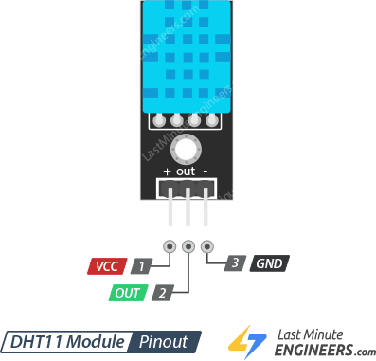

+ (VCC) pin supplies power for the sensor. 5V supply is recommended, although the supply voltage ranges from 3.3V to 5.5V. In case of 5V power supply, you can keep the sensor as long as 20 meters. However, with 3.3V supply voltage, cable length shall not be greater than 1 meter. Otherwise, the line voltage drop will lead to errors in measurement.

Out pin is used to communication between the sensor and the Arduino.

– (GND) should be connected to the ground of Arduino.

**Expected Output**

